Location Selection of Opening a Bubble Tea Shop in

San Jose, CA

**1. Introduction:**

* Asian cuisine is also very popular in the US, especially cities full of Asian immigrants, like the Silicon Valley in California.
* Bubble tea is growing more and more popular, bubble tea stores often have a long queue in some hot business areas
* This project aims to find the best location to open a business in a city in Silicon Valley, San Jose, CA
* It’s important to know if it is profitable prior to launching any business, so this report will try to gather data about similar businesses in the neighborhood and potential customer distribution, competitors, etc.
* The data can be used as part of a business plan to support making decision

**2. Data Description:**

* I will use Foursquare API to find venues:
* For competitor study
  + Existing Bubble Tea shops around the neighborhoods in San Jose
  + Similar businesses around the neighborhoods in San Jose
* For potential customer distribution study
  + Universities around the neighborhoods in San Jose
  + Companies around the neighborhoods in San Jose
* Data visualization: I will use folium the map rendering library to visualize the venues

**3. Methodology:**

1. City partitioning

Create a hexagonal grid of cells: offset every other row, and adjust vertical row spacing so that every cell center is equally distant from all its neighbors.

All following data manipulations are operated against each of the cells

1. Get all bubble tea shops and coffee shops/Cafe in each area cell using the foursquare API (category approach)
2. Find potential customer spots in each area cell with foursquare API category approach (universities and companies)
3. Candidate place can be found among the areas that have highest customer/existing-biz ratio
4. Use heatmap to visualize the outstanding areas
5. Use Kmeans cluster approach to zoom to get the result set of location

**4. Exploratory Data Analysis:**

1. Existing business situation

* Total number of bubble tea shops: 32
* Total number of other coffee shops or cafes: 0
* Percentage of bubble tea shops in the tea/coffee biz: 100.00%

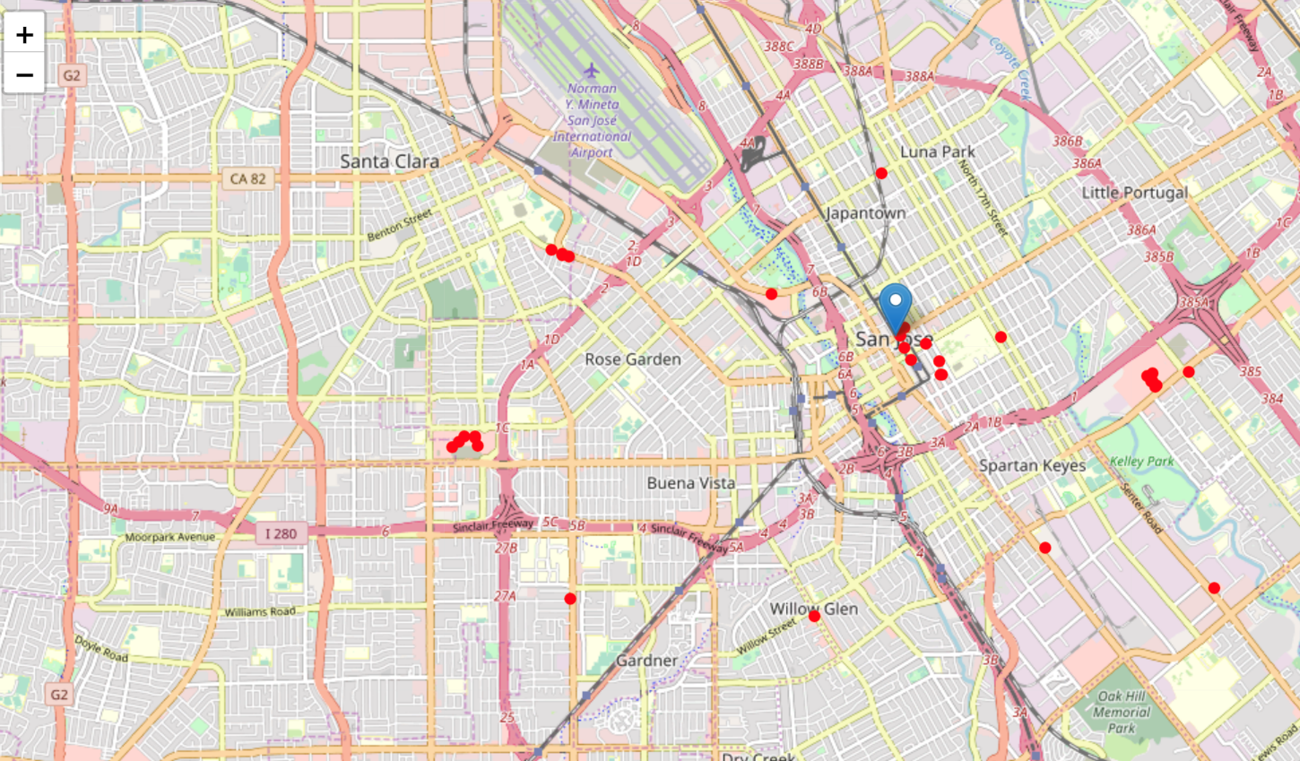

1. Potential customer cluster situation

* Total number of universities: 199

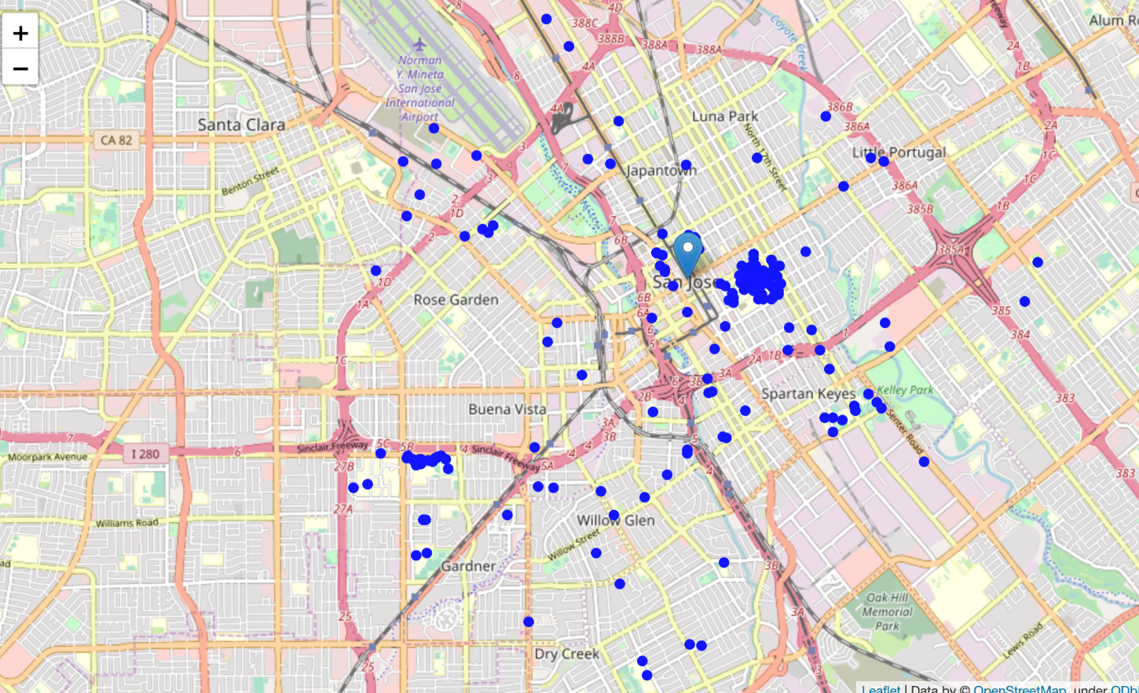

* Total number of companies: 2582

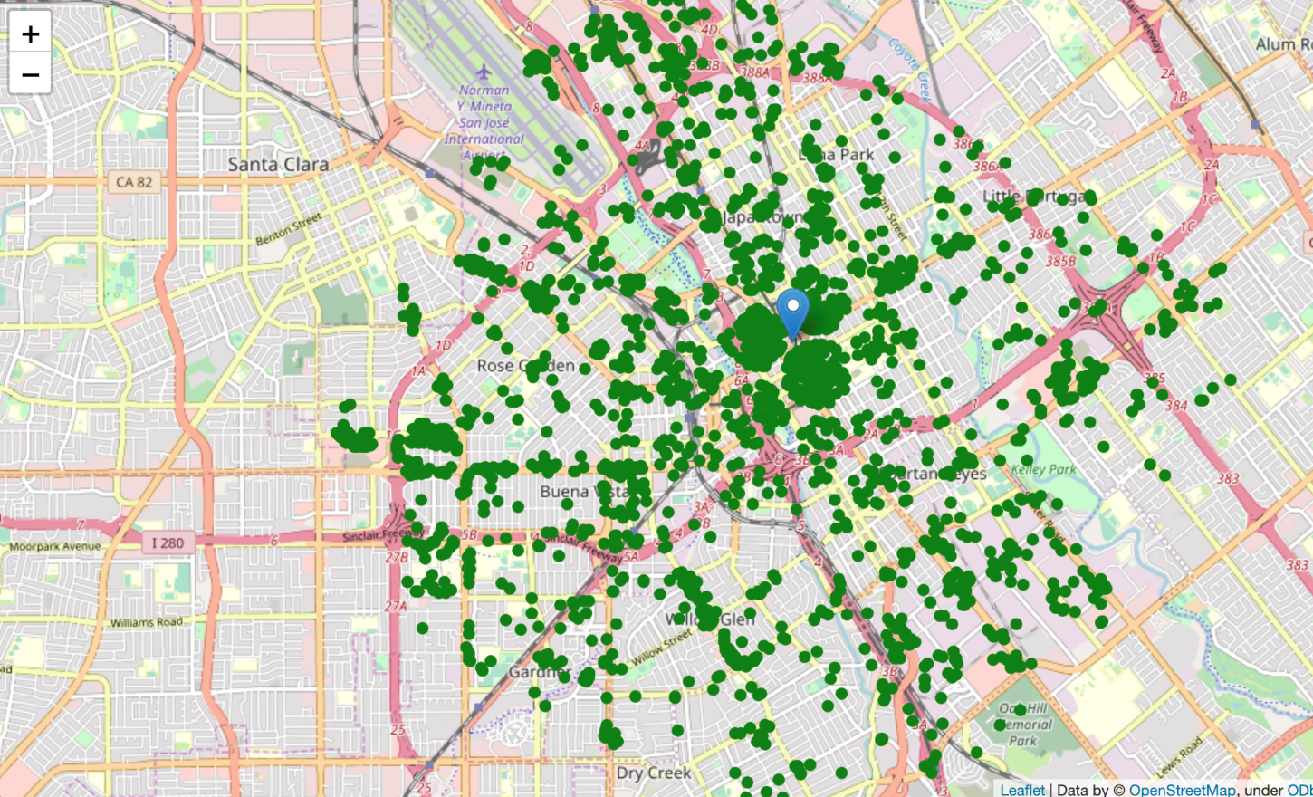

1. Candidate areas that have profit potential are the ones have **highest customer-density and least competitors**

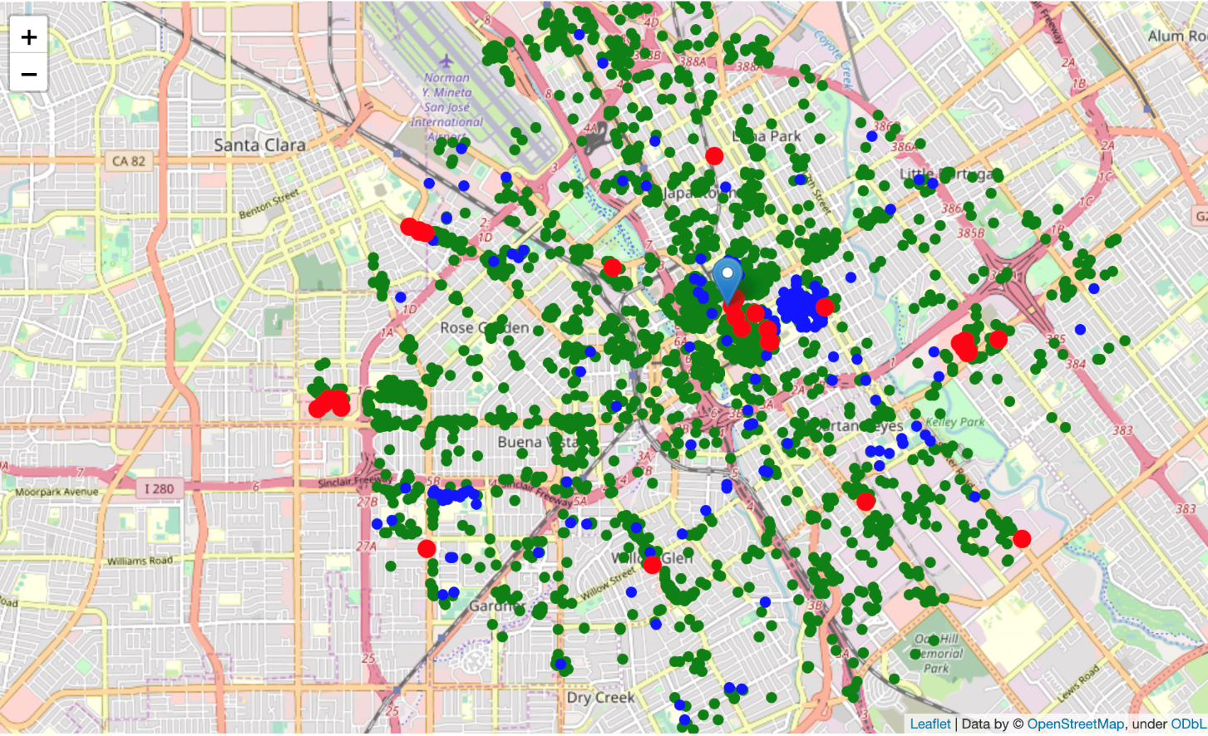

1. Then we list the top 10 customer dense areas

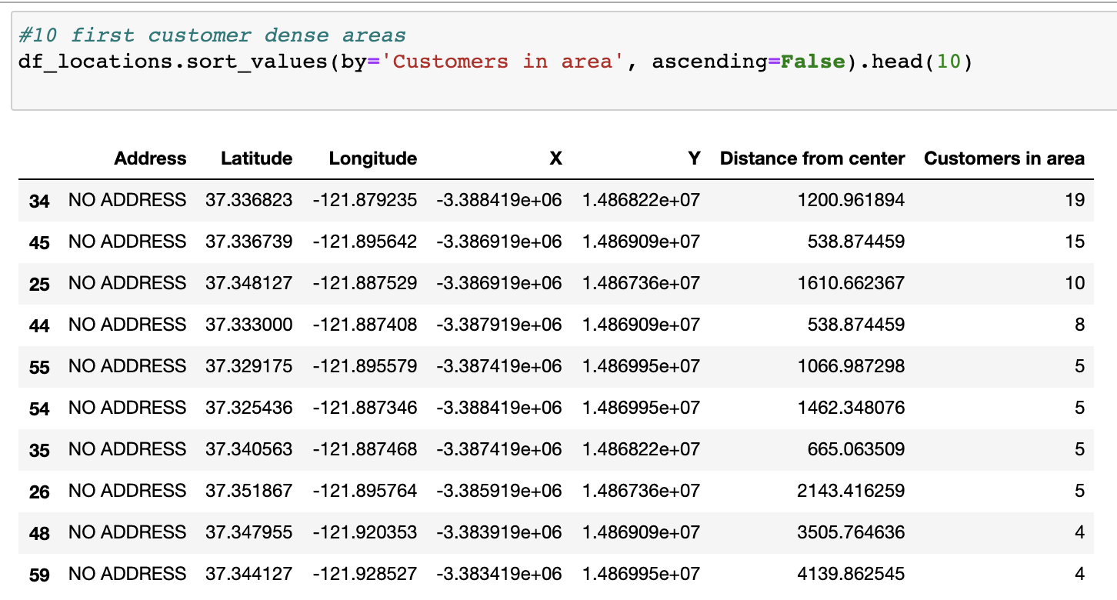

1. We see that the customer-dense areas are all around the center of city San Jose

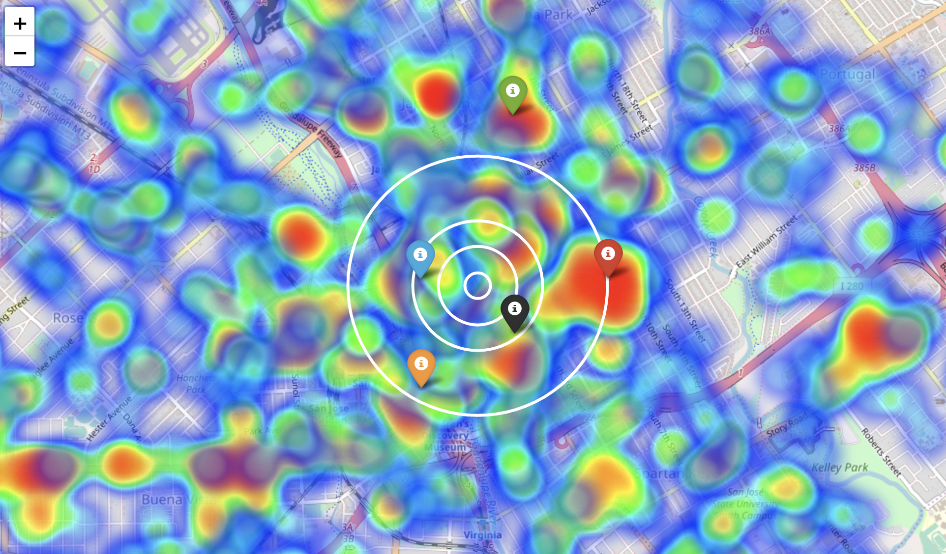

**7. Result and Discussion:**

* From prior exploration we can see that candidate location should still be focus around the center of the city
* We zoom in to calculate all the data for each venue of the neighborhood
* 563 candidate neighborhood centers generated

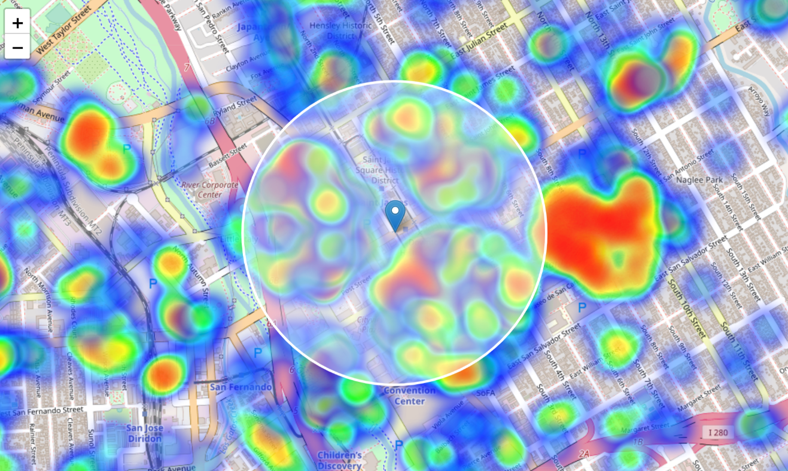

* Then among the 563 location candidates we calculate:
* Number of bubble tea shops in the vicinity (radius = 150 meters)
* Number of customers

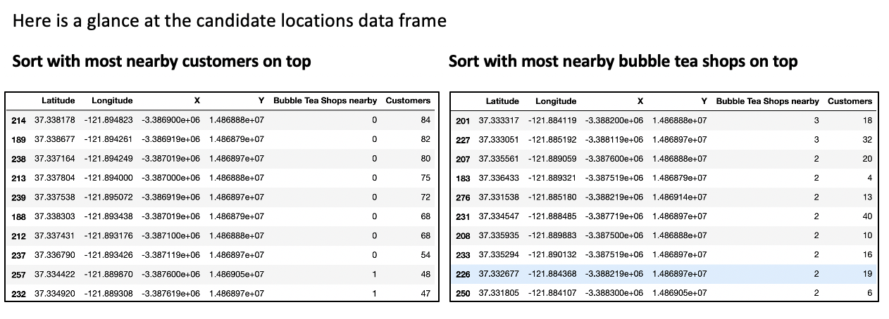

* Select the good ones meet both conditions below:
* Locations have less than 1 (including) bubble tea shops nearby.
* Locations have more than 20 customers

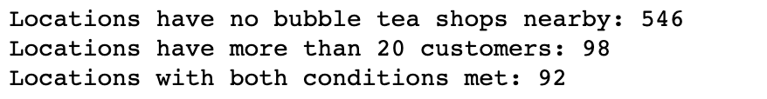

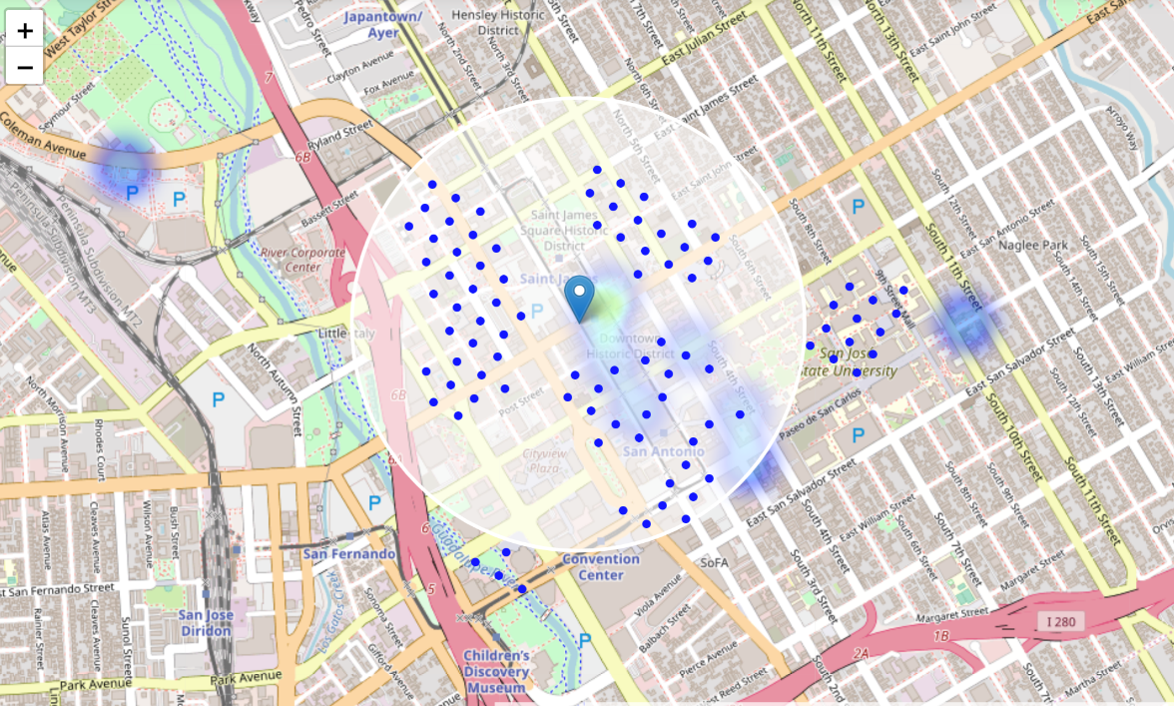

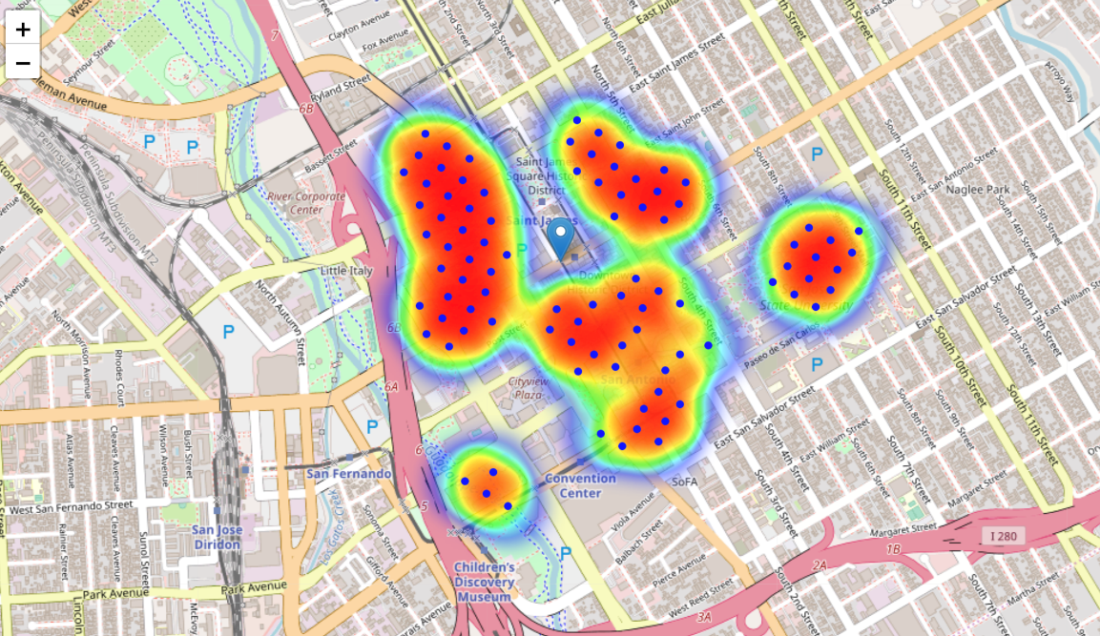

We now have a clear indication of areas with low number of bubble tea shops nearby and good numbers of customers.

Let's cluster those locations with K means to create centers of zones containing good locations. Those zones, their centers and addresses will be the final result of our analysis.

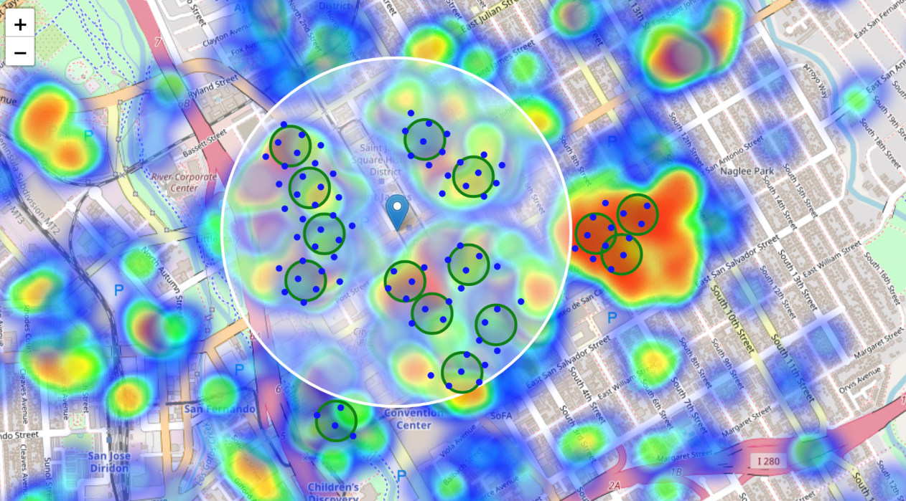

The clusters represent groupings of the candidate locations and cluster centers are placed in the middle of the zones 'rich' with location candidates.

Addresses of the cluster centers will be a good starting point for exploring the neighborhoods to find the best possible location based on neighborhood specifics.

Let's see those zones using shaded areas to indicate the clusters:

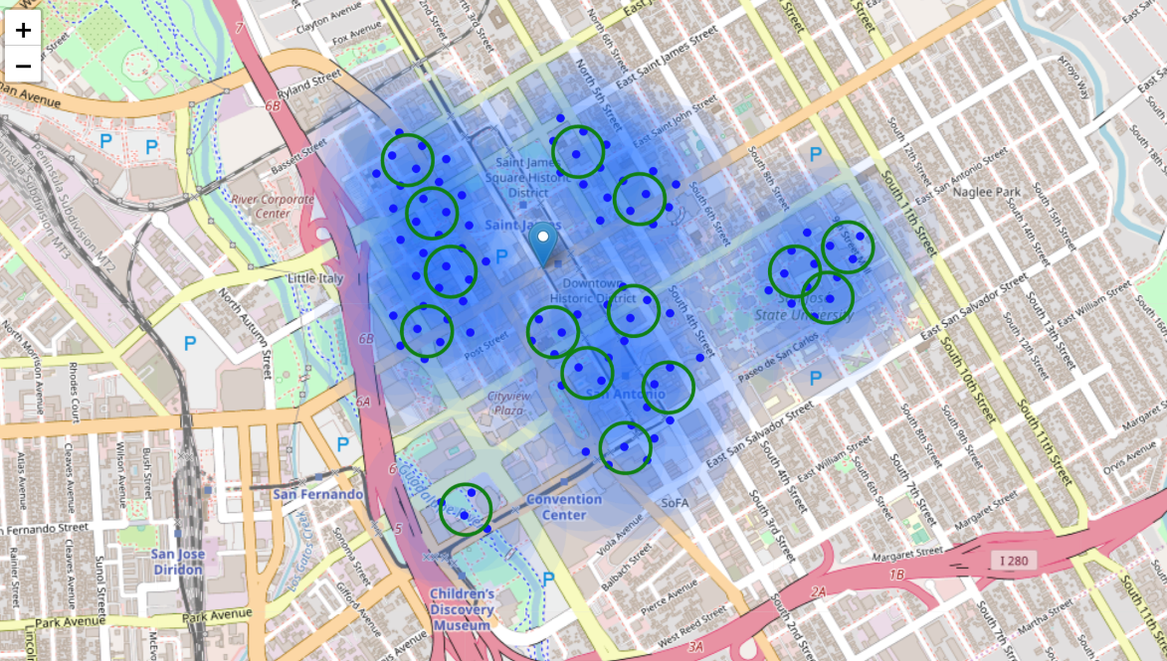

Below is the list of latitude/longitude of the cluster centers, which is our desired final result set. User can easily find geocode converter on the internet to transform them into addresses, or use Google cloud API (It requires credit card information to create billing account, which I didn’t do)

[(-121.89537395222014, 37.339289648214105),

(-121.88731033435064, 37.3350177293404),

(-121.88039257430975, 37.33539209504962),

(-121.88928925207554, 37.33952741630228),

(-121.8933012401226, 37.32938658417022),

(-121.89383752411624, 37.33612939579999),

(-121.89468304830832, 37.33444102449878),

(-121.88760428815883, 37.331132309302276),

(-121.88896272037618, 37.33325632393298),

(-121.88709700301852, 37.3381863406691),

(-121.88155550076652, 37.336135699430486),

(-121.89018704724414, 37.33441517945734),

(-121.89450565474245, 37.337782937174474),

(-121.88607274905321, 37.332848052144),

(-121.8796683429025, 37.33682142543998)]

**8. Conclusion and Future Directions:**

The above analysis can be a good start for business feasibility evaluation, there must be other aspects to consider, the criteria we used for filtering may vary as we investigate further for the business environment which can not be fully covered in this report. To be prudent, it can always be good to cross check data with other data sources.

To be more accurate, it could be possible to give a weight to customers, since younger people who work in a high-tech company have totally different consumer habits from the ones who work in a traditional industry

This project can be reused for other cities, other lines of businesses. User will just need to adjust the parameters, values, criterias to fit their needs.

.